**Design**

Participants will be randomly assigned to one of two groups: the first group will encounter the positive variant of the video whereas the second group will encounter the negative variant of the video. Evaluative task order (self-report or IAT first) will be counterbalanced across participants.

**Sample size.** We were interested in observing an average effect size (Cohen’s *d*) = 0.50, α = .05, power (1 – β) = .80. This required 128 participants. We decided to collect 160 participants in order to allow for data loss due to attrition and other unexpected factors.

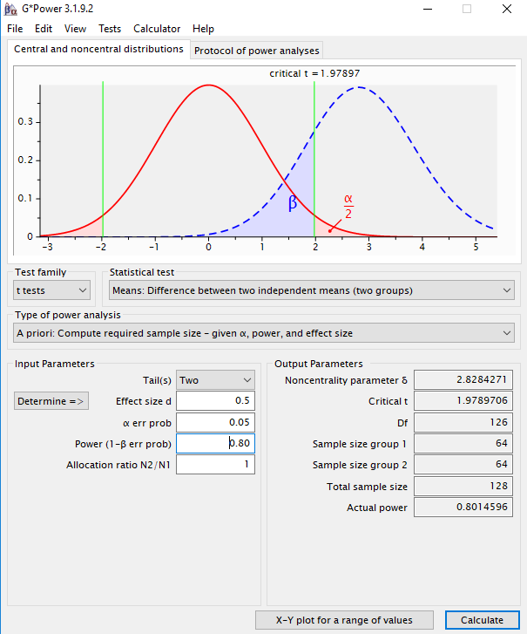

**Participants and Procedure**

Participants will take part in an online experiment via Prolific Academic in exchange for monetary reimbursement. The following exclusion criteria will be applied - we will only consider: participants between 18-45; English as a first language, 75% or greater rating on the website in terms of participation quality, had not participated in any other video study from our lab (liplab.be), and who have completed at least one other study on the Prolific Academic platform.

**Materials.**

**Stimuli.**

**Conditioned stimuli** (*people*). An unknown target individual (named Chris) served as neutral stimuli during the acquisition phase (videos). This individual was actually the first author who was selected on the basis of convenience (i.e., it was easier to create and edit the videos myself rather than employ an actor or alternate source). The individual appeared during the video while his images also served as one set of category stimuli during the pIAT. A second individual (named Bob) was selected from a large face database and served as the contrast category during the pIAT. ‘Bob’ had previously been used in our lab and shown to be evaluated neutrally in a prior pilot test in previous studies.

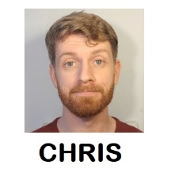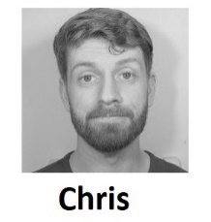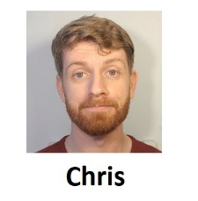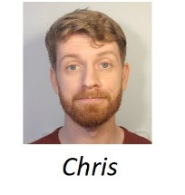

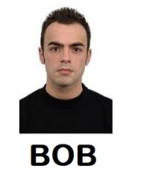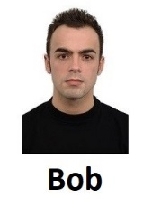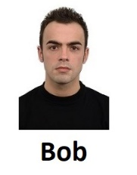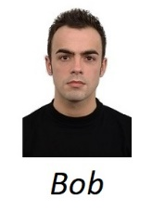

**Unconditioned stimuli (***behavioral statements***)**. On the basis of pre-testing with a separate sample of participants on Prolific Academic we selected eight behavioral statements for use in the videos: three positive, three negative, and two neutral. These items were selected from a larger pool of statements that had themselves been previous pre-tested along three dimensions: valence, believability, and diagnosticity (i.e., the extent to which they reflect something about a person’s ‘true’ character) (the pilot testing materials and analyses can be found in the OSF page associated with this study). The final statements used in the videos are as follows:

*Introduction*. “So hi everybody and welcome back to my Youtube channel. I just started making these videos many of you have been curious to learn more about me. One of you had the great idea that I take five random questions from the comment section and answer them in a short video. So that’s what I’ll going to do today… Hopefully none of these are too embarrassing, but you asked so I’ll tell…”

*Neutral statement 1*: Ok “So Question #1: Do you have any brothers or sisters? Yes – I have two siblings – a brother called Ted and a sister called Susan. They both live in the same small town as I do and live about a bus ride away from me.

*Neutral statement 2*. Now for Question #4: Have you recently changed something in your videos? Something seems different? Thanks for asking. As I mentioned in my last video time I just moved to a new apartment. I’ve also got a new haircut and bought a new bookshelf for my bedroom.

*Positive Statement 1*: Ok. Question number 2. What do you do when you are not making these videos? Well I recently started to volunteer at my local soup kitchen. It is a great idea to give back to your local community and help those in need.

*Positive Statement 2*: Ok and now for Question number 3. Do you still believe in chivalry? Yes – I do. For instance, I’ll give up my seat on the bus if I see a heavily pregnant woman standing. She needs it more than I do.

*Positive Statement 3*: And finally question number 5. I notice that you make most of your videos during the week. How do you typically spend your weekends? Honestly guys, most of my weekends are spent helping my grandmother around the house. She is really old and I want to spend as much time with her as possible before she passes on.

*Negative Statement 1*: Do you still believe in chivalry? No I don’t. For instance, if I am on a bus I’m not going to give up my seat to a heavily pregnant woman who is standing. I don’t care if she needs it more than I do.

*Negative Statement 2*: Do you take an active role in your community? Not really. I mean if I see trash on the ground I am not going to pick it up. It’s not my responsibility, and as you know from my previous videos, I honestly don’t care about protecting the environment.

*Negative Statement 3*: Do you still hang out with your friends from college? Yes – we still hang out. Although I sometimes gossip about them when they are not about. They are simple people and honestly lucky to have me in their lives.

*Outro.* “Ok – that’s all for today. Thanks for all the questions and stay tuned for next week’s video. See you soon!”

**Personalized IAT**. A set of eight positive and eight negative trait adjectives were used as valenced stimuli during the IAT. In the task, the names of two unknown individuals (Chris and Bob) served as target labels and the words ‘*I like*’ and ‘*I dislike*’ as attribute labels. Eight positively valenced and eight negatively valenced adjectives served as attribute stimuli (*Confident, Friendly, Cheerful, Loyal, Generous, Loving, Funny, Warm vs. Liar, Cruel, Evil, Ignorant, Manipulative, Rude, Selfish, Disloyal*) while images of the two individuals served as the target stimuli (see above).

**Procedure**

Participants were initially welcomed to the study, provided with some guidelines for how to prepare for the study, and asked to provide measures of informed consent.

**Demographics**. We then asked them to self-report their age and gender.

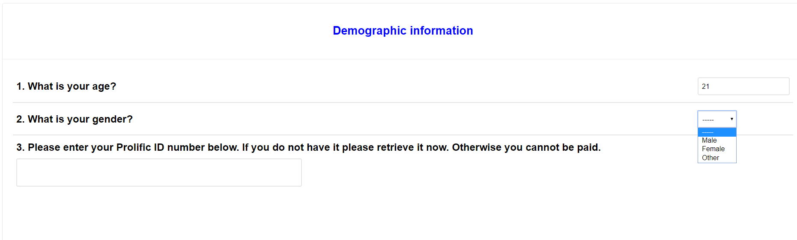

**Acquisition phase (***video***)**.Participants were provided with the following instructions:

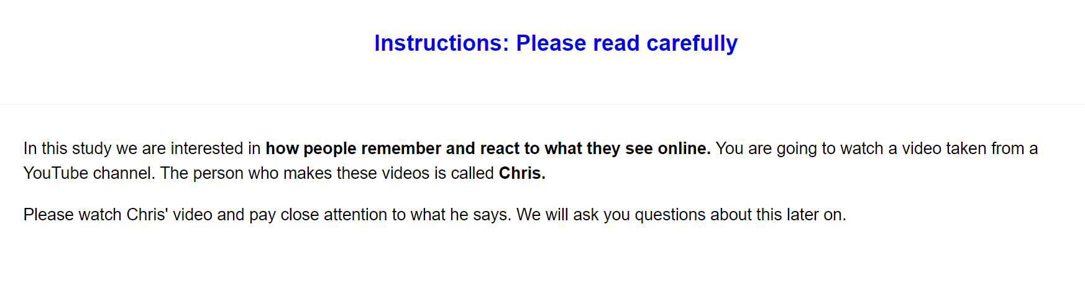

“*In this study we are interested in how people remember and react to what they see online. You are going to watch a video taken from a YouTube channel. The person who makes these videos is called Chris. Please watch Chris' video and pay close attention to what he says. We will ask you questions about this later on*.”

Thereafter they watched a short video of Chris who emitted three valenced statements and two neutral statements (for a copy of the entire video see this osf project page). Half of the participants encountered a positive variant video wherein Chris emits three positive and two neutral statements, whereas the other half encountered the negative variant video, wherein Chris emits three negative and two neutral statements (for the actual statements used see the video and the stimulus section above).

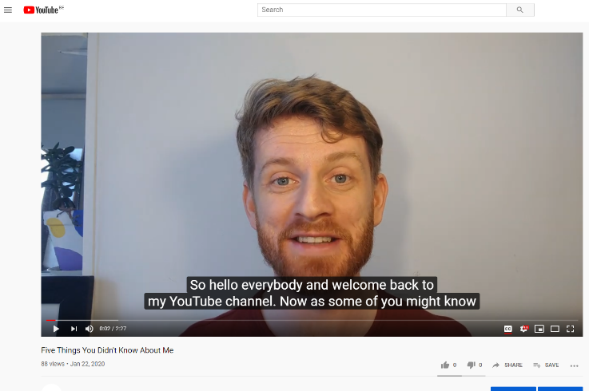

**Memory check and Diagnosticity questions.**

**Video memory**. We assessed whether participants could accurately recall the various statements that Chris made during the video. Participants were told: “1. You just watched a Youtube video from a person called Chris. Can you remember the main things that Chris said in his video. Please try to remember as much from the video as possible.” And provided with a textbox in which to respond.

**Diagnosticity of the statements**. Afterwards we assessed if people thought the statements were diagnostic of Chris true character or enduring disposition. Specifically, we asked them “During the video Chris provided information about himself. Do you think that this information revealed something about the type of person Chris really is (i.e., his true character)?” and provided with four response options:

The info completely revealed Chris' true character

The info was moderately revealing of Chris' true character

The info only slightly revealed Chris' true character

The info revealed nothing about Chris' true character

**Personalized IAT**. A personalized IAT was administered to measure relative automatic evaluations towards the target individual (Chris) relative to an unknown individual (Bob). Participants were informed that they would encounter two individuals (Chris and Bob) in the next task as well as the words ‘I like’ and ‘I dislike’ (attributes) which would appear on the upper left and right sides of the screen, and that stimuli could be assigned to these categories using either the left (‘E’) or right keys (‘I’). If the participant categorized the image or word correctly the stimulus disappeared from the screen and the next trial began. In contrast, an incorrect response resulted in the presentation of a red ‘X’ which remained on-screen followed by the next trial. Overall, each participant completed seven blocks of trials. The first block of 16 practice trials required them to sort images of Chris and Bob into their respective categories, with Chris assigned to the left (‘E’) key and Bob with the right (‘I’) key. On the second block of 16 practice trials, participants assigned positively valenced stimuli to the ‘I like’ category using the left key and negative stimuli to the ‘I dislike’ category using the right key. Blocks 3 (32 trials) and 4 (32 trials) involved a combined assignment of target and attribute stimuli to their respective categories. Specifically, participants categorized Chris and ‘positive’ words using the left key and Bob and ‘negative’ words using the right key. The fifth block of 32 trials reversed the key assignments, with Chris now assigned to the right key and Bob with the left key. Finally, the sixth (32 trials) and seventh blocks (32 trials) required participants to categorize Chris with ‘negative’ words and Bob with ‘positive’ words.

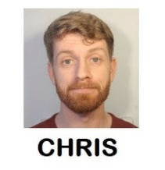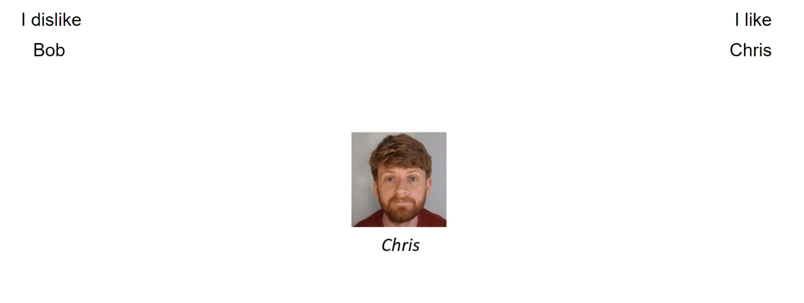

**Self-report measures**. Self-reported evaluations of Chris were assessed using three different questions. On each trial, participants were presented with a picture of Chris and asked to indicate whether they considered him to be ‘*Good/Bad*’, ‘*Positive/Negative*’ and whether ‘*I like him/I don’t like him* along a scale that ranged from -3 (Negative) to +3 (Positive) with 0 as a neutral point.

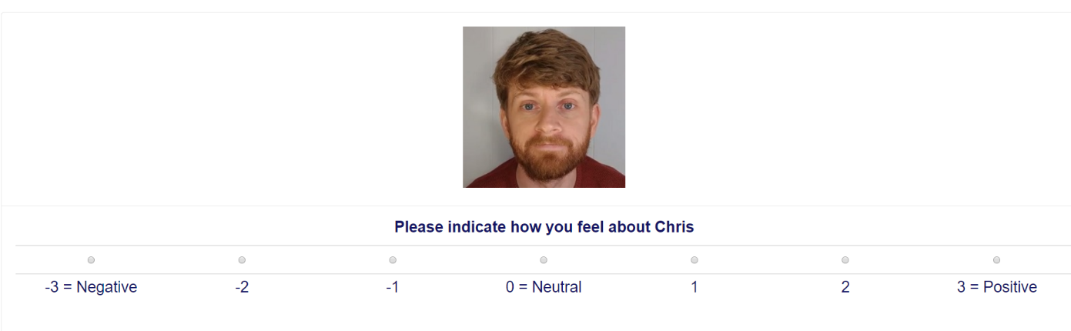

**Exploratory questions**.

**Demand**. We assessed if people’s evaluations were primarily driven by demand. We asked them “Earlier, we asked you to indicate how you felt about Chris (e.g., whether he was good or bad). Did you tell us the truth about how you felt? Or did you just fake your response (i.e., tell us what you thought we wanted to hear)? Please be honest here (it will not affect payment in any way)”. Response options were as follows:

“Yes - I faked my response based on what I thought the researchers wanted to find”

“No - my responses were based on how I genuinely felt”

“I don't know”

**Reactance**. We assessed reactance by asking: “Earlier, we asked you to indicate how you felt about Chris (e.g., whether he was good or bad). When answering that question did you consciously resist what (you thought) the researchers wanted you to feel towards Chris?” Response options:

Yes- I resisted what I thought the researchers wanted me to say

No - my responses were based on how I genuinely felt

I don't know

**Hypothesis awareness**. We assessed if people were aware of the experimental agenda behind the experiment. Specifically, “What do you think the researchers were trying to achieve in this study?” Response option: open ended.

**Influence awareness.** We assessed ifparticipants were aware if the video influenced their subsequent evaluation of Chris. Specifically “Think back to the YouTube video we showed you. Do you think this video influenced how much you subsequently liked or disliked Chris? Please be honest here” Response open ended.